How to Print a Registration Receipt
Step 1:  Log in to the web site with your member username and password. | 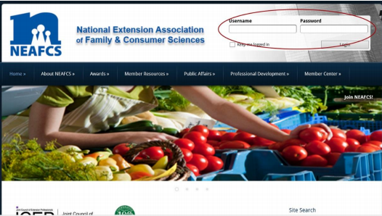
Step 2:  Select the tab My Profile, which can be found under the Member Center tab. | 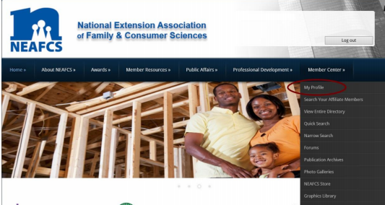
Step 3:  Select the View Transactions tab, which can be found under the My Profile tab. | 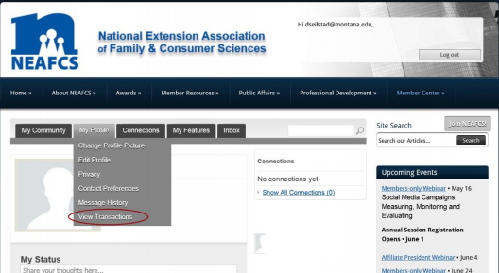
Step 4:  Select the button Receipt next to your Annual Session Registration. | 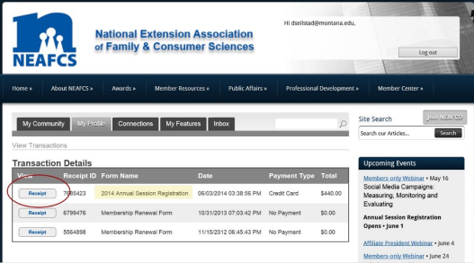
Step 5:  After you select the Receipt button, your receipt will appear, and you can print it from the Print link in the upper right corner. | 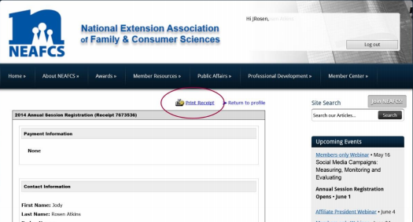

If you have any problems viewing your receipt, please try a different computer, internet browser, or upgrade your browser level.

