NEAFCS 85th Anniversary Pin Purchase and Payment Authorization Form
Name ___________________ ___________________ Daytime Phone __________________________
Email ______________________________________

□ I will pick up my Pin at the upcoming Annual Session
□ I will pay for shipping to have my Pin sent to me directly.
Shipping Address
Items for which payment is authorized:
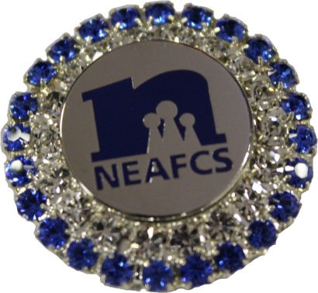 | Special 85th Anniversary Pin is available in limited quantities. Purchase your pin today to add to your collection!  # of Pins __________ x $40.00 each = $_____________

Payment Method:
ο Cash Amount $ ____________
ο Check (payable to NEAFCS) Amount $ ____________ Check Number ________
ο Credit Card Amount $ ____________ Card Type
ο Add Shipping Amount $ ____5.00___
Total $ ____________
Credit Card Authorization:
I authorize NEAFCS to debit my credit cards for the amount referenced above.
Name on credit card ___________________________________________
Credit card number ____________________________________________
Expiration Date _________________________ Security Code __________
Billing address ________________ _______________________________
City, State, Zip ______________ ________________________________
Email of the person on the credit card if different than above _______ ____________________________
Phone number of the person on credit card if different than above ___________________________

Signature of the Person on the credit card:

__________________________________________ ______ Date ______________________

We will not process this payment without the signature of the person named on the credit card.

