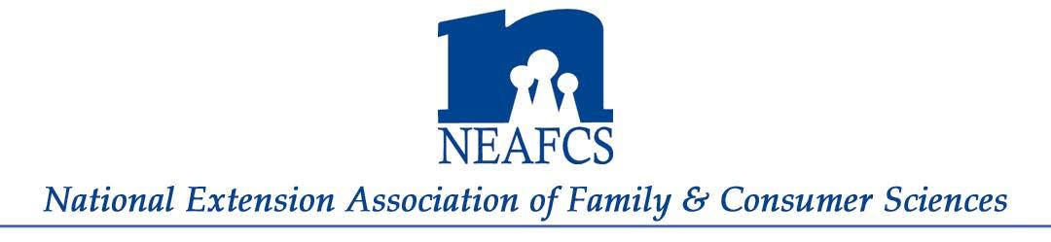
The Purpose of the association is to provide a professional organization for Extension professionals in Family & Consumer Sciences who work in family related programs or administration, to promote professional growth and development.
The Vision
- Voice for professionals in Extension Family & Consumer Sciences program development
- Provide an information network for its members
- Provide continuing education for Extension professionals
- Recognize Extension professionals through awards and recognition
The Benefits
- Opportunity to develop leadership and management skills
- Access to professional development, sharing and networking on MN Affiliate and national levels through webinars, Annual Session, newsletters, blogs, social media, etc.
- Recognition for outstanding achievements through awards and acknowledgement
- Exchange educational programming, ideas and methods through peer review process
- Forum and network to discuss common Extension concern
- Opportunity to develop lasting friendships with those who do similar work
NEAFCS Membership Options Active Member – Extension employees working in any capacity with family and consumer sciences programming with a minimum of a Bachelor’s degree can join as an Active Member. Annual dues of $120 includes membership and involvement in all opportunities and activities on the Minnesota Affiliate and national levels.
Minnesota Affiliate Active Member – Extension employee working as a SNAP-Ed Coordinator or Educator, Community Nutrition Educator, Financial Capability Educator, or similar position with or without a Bachelor’s degree can join as a Minnesota Affiliate Active Member. Annual dues of $40 include Minnesota Affiliate involvement such as holding an office, serving on a committee, voting on state level issues, and receiving state level awards. This provides MN Affiliate membership only, no national level membership or involvement.
Life Member – Those who have been an active member for at least five (5) years and have retired, resigned or otherwise ineligible for active membership can join as an NEAFCS Life Member. One-time dues of $300 include Minnesota Affiliate and national life membership.
Minnesota Affiliate Life Member – Those who have been an active member for at least five (5) years and have retired, resigned or otherwise ineligible for active membership can join as an NEAFCS Minnesota Affiliate Life Member. One-time dues of $50 for Minnesota Affiliate membership only, no national membership or involvement.
For More information
Contact Kathy Brandt, NEAFCS-MN Affiliate President, at brand030@umn.edu or (507) 337-2820.

November 2019

