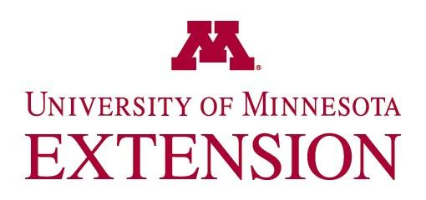
NEWS & INFORMATION

“Living Well” is the focus of University of Minnesota Extension Educators across Minnesota

YOUR TOWN, Minn. (MONTH/DATE/YEAR)

“Living Well” is the focus of University of Minnesota Family & Consumer Science Extension Educators across Minnesota. Extension educational programs focus on raising kids, healthy and safe food, spending smart and living well. The Extension Association of Family and Consumer Sciences, both at the national level and in Minnesota, promote the Living Well Campaign, celebrated in March. “Minnesota Extension Association of Family and Consumer Science professionals work through the University of Minnesota Extension program to offer education and resources to help families and communities achieve a positive healthy lifestyle to live well,” says Marshall Extension food safety educator, Kathy Brandt, current president of the Minnesota Affiliate. “Whether you are trying to stretch your food dollar through meal planning, make decisions about financial planning, or need tips to start a home-based food business, Extension has a research-based answer,” she added. Here are some of the educational programs and resources developed and taught by University of Minnesota Extension family and consumer science educators to help Minnesotans live well:
- Family resource management educators, Lori Hendrickson (Grand Rapids) and Becky Hagen Jokela (Cloquet), developed and teach the train-the-trainer RentWise curriculum to human service professionals. After attending the training, 98% of participants (2017-2019) indicate they felt prepared to teach their clients to be successful renters.
- Children build connections between growing and eating fresh fruits and vegetables through hands-on gardening, science, and nutrition education through the Children’s Garden in Residence Summer Program. Anna Sneltjes (St. Cloud) was one of many SNAP-Educators (Supplemental Nutrition Assistance Program Education) who partnered with Master Gardeners, 4-H, and youth-serving organizations to share their expertise with 588 children across 17 Minnesota counties.
- Providing healthier food options with dignity and respect at food shelves is a priority for Extension nutrition educators, Kelly Kunkel (Mankato), Megan Hruby (Crookston) and Anna Sneltjes (St. Cloud). Through training, technical support and changing the food environment, food shelves in 27 counties across Minnesota serve their clients in new and innovative ways to make the healthy choice the easy choice.
- SNAP-Ed Educators, like Donna Anderson (Park Rapids) provide colorful tastings monthly to 3rd through 5th graders in 50 Minnesota schools. After participating in the Go Wild with Fruits and Vegetables program, students increased their daily fruit intake by 1/3 cup.
- Health and nutrition educators, Mary Schroeder (Marshall) and Kelly Kunkel (Mankato) teach the Start Strong: Cooking, Feeding, and More to Minnesota child care providers. They learn to food preparation skills, meal planning and alternative cooking techniques to create healthy food environments for children. After the training, 91 childcare providers indicate greater confidence and ability to prepare healthy food for the 400 children they serve. Seventy percent of the providers state they write their menu ahead of time compared to only 40% prior to receiving the training.
Visit the University of Minnesota Extension website to find these and other programs to help you live well. http://www.extension.umn.edu/.
------------------------------------------------------------------------------------------------------------------
Extension Family and Consumer Science professionals are part of a nationwide educational organization funded through the Land Grant University System and United States Department of Agriculture. Local Extension Family and Consumer Sciences professionals provide practical, relevant, unbiased, research-based information.
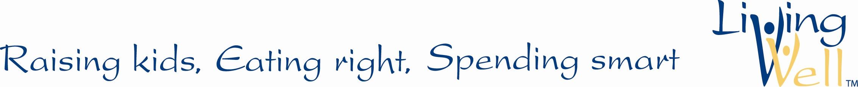
------------------------------------------------------------------------------------------------------------------
Source: YOUR NAME, TITLE, EMAIL ADDRESS, OFFICE LOCATION AND PHONE NUMBER
University of Minnesota Extension is an equal opportunity educator and employer.

